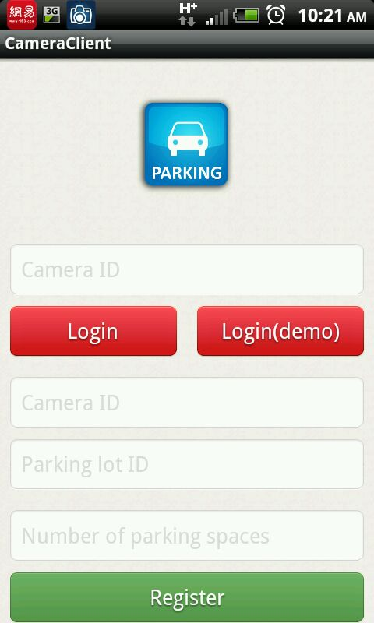
1. Take background picture
2. Input with camera ID
3. Login the server database
4. Login the server temporary variable
5. Input the register information
6. Register the server temporary variable

Index page

How to use this app to start monitoring a parking lot?

Step 1. Input the camera information in dialog box 5. Camera ID should be integer number, Parking lot ID should be String, Number of parking spaces should be a Integer number. Example(100, Kelley, 3).

Step 2. Take a background photo by pressing button 1. After press button 1, you will see the following : Press the Take Picture button to take the background picture, then press the save button to save the picture you just took. Press the cancel button to go back to the index page.
(Please note: After you take background picture, you should not move the cell phone any more)



Step 3: Connect your cell phone to the laptop. The background picture and configuration file is in the directory of /Picture/CameraApp/. Open Background.jpg file, the picture looks like:
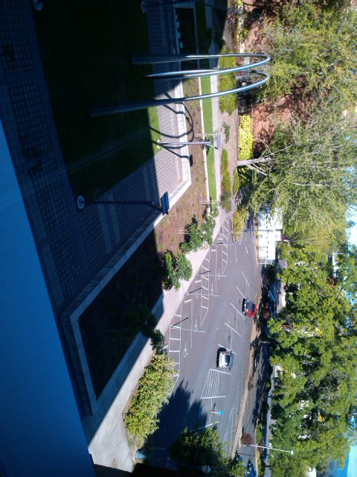
(316,390)
(309,414)
(301,441)
Record the left top corner coordinates of each parking space ROI(region of interest). Then open the config.txt file, the first line is the size of ROI, the following lines is the coordinates you just recorded.

Step 4. Disconnect your device, open the index page again, login with your camera ID and press Login(demo) button (4). Please note Login(demo)(4) means using server temporary variable, Login(3) means using server database. If you want to using server database, you need register all the parking lots information on the server side, not just register in this app.

Step 5. Once login successfully, press start button and this app will begin to work(Take picture every 10 seconds, calculate the image information and update the information to the server side).

Client app UI(demo)
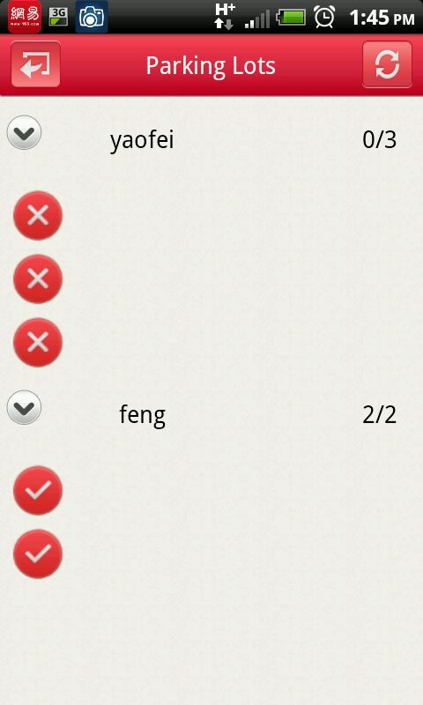
Refresh button.
Available / Total
Parking lots name
Quit
X means unavailable
Hook mean available

Client app UI with Google map
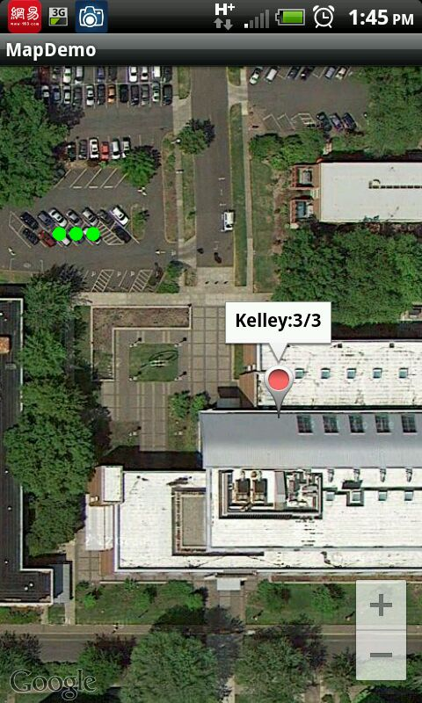
You can get the parking lots information by a dropped pin in google map
Since all the coordinates information is stored in our database, each parking space available can be displayed in google map. Green point means available and red point means unavailable.

